

# 

### Semester Two Examination, 2019

### Question/Answer booklet

# MATHEMATICS

**APPLICATIONS**

**UNITS 1 AND 2**

## Section One:

## Calculator-free

Your name

## Teacher name (please circle) Hennighan Hill Scorer Toh

## Time allowed for this section

Reading time before commencing work: five minutes

Working time: fifty minutes

## Materials required/recommended for this section

***To be provided by the supervisor***

This Question/Answer booklet

Formula sheet

***To be provided by the candidate***

Standard items: pens (blue/black preferred), pencils (including coloured), sharpener,  
correction fluid/tape, eraser, ruler, highlighters

Special items: nil

## Important note to candidates

No other items may be taken into the examination room. It is **your** responsibility to ensure that you do not have any unauthorised material. If you have any unauthorised material with you, hand it to the supervisor **before** reading any further.

## Structure of this paper

|  |  |  |  |  |  |
| --- | --- | --- | --- | --- | --- |
| Section | Number of questions available | Number of questions to be answered | Working  time (minutes) | Marks available | Percentage of examination |
| Section One:  Calculator-free | 8 | 8 | 50 | 52 | 35 |
| Section Two:  Calculator-assumed | 13 | 13 | 100 | 98 | 65 |
|  | | |  | **Total** | 100 |

|  |  |  |
| --- | --- | --- |
| Markers use only | | |
| Question | Maximum | Mark |
| 1 | 6 |  |
| 2 | 6 |  |
| 3 | 7 |  |
| 4 | 9 |  |
| 5 | 7 |  |
| 6 | 5 |  |
| 7 | 6 |  |
| 8 | 6 |  |
| S1 Total | 52 |  |
| S1 Wt (×0.6731) | 35% |  |
| S2 Wt | 65% |  |
| Total | 100% |  |

## Instructions to candidates

1. The rules for the conduct of examinations are detailed in the school handbook. Sitting this examination implies that you agree to abide by these rules.

2. Write your answers in this Question/Answer booklet preferably using a blue/black pen.  
Do not use erasable or gel pens.

3. You must be careful to confine your answer to the specific question asked and to follow any instructions that are specified to a particular question.

4. Show all your working clearly. Your working should be in sufficient detail to allow your answers to be checked readily and for marks to be awarded for reasoning. Incorrect answers given without supporting reasoning cannot be allocated any marks. For any question or part question worth more than two marks, valid working or justification is required to receive full marks. If you repeat any question, ensure that you cancel the answer you do not wish to have marked.

5. It is recommended that you do not use pencil, except in diagrams.

6. Supplementary pages for planning/continuing your answers to questions are provided at the end of this Question/Answer booklet. If you use these pages to continue an answer, indicate at the original answer where the answer is continued, i.e. give the page number.

7. The Formula sheet is not to be handed in with your Question/Answer booklet.

Section One: Calculator-free 35% (52 Marks)

This section has**eight (****8)** questions. Answer **all** questions. Write your answers in the spaces provided.

Working time: 50 minutes.

Question 1 (6 marks)

(a) Simplify $2+4×\sqrt{36}-20÷2^{2}$. (2 marks)

(b) Determine the value of the expression $\begin{matrix}x^{2}+2x \\ \overline{y^{2}-3y}\end{matrix}$ when $x=5$ and $y=-2$. (2 marks)

(c) Determine the value of $d$ when $a=2.8, v=0.5$ and $d=6v^{2}-2av$. (2 marks)

Question 2 (6 marks)

An airport car park charges the amounts shown in the table below for periods not exceeding $24$ 
 hours.

|  |  |  |  |  |
| --- | --- | --- | --- | --- |
| Parking time | No more than $3$ hours | More than $3$ but not exceeding $6$ hours | Each additional hour (or part) exceeding $6$ | Maximum charge for up to $24$ hours |
| Charge | $$\$25$$ | $$\$35$$ | $$\$5$$ | $$\$65$$ |

(a) Explain why the charge to park a car for eight and a half hours is $\$50$. (2 marks)

(b) Draw a graph to represent the parking charges on the axes below. (4 marks)

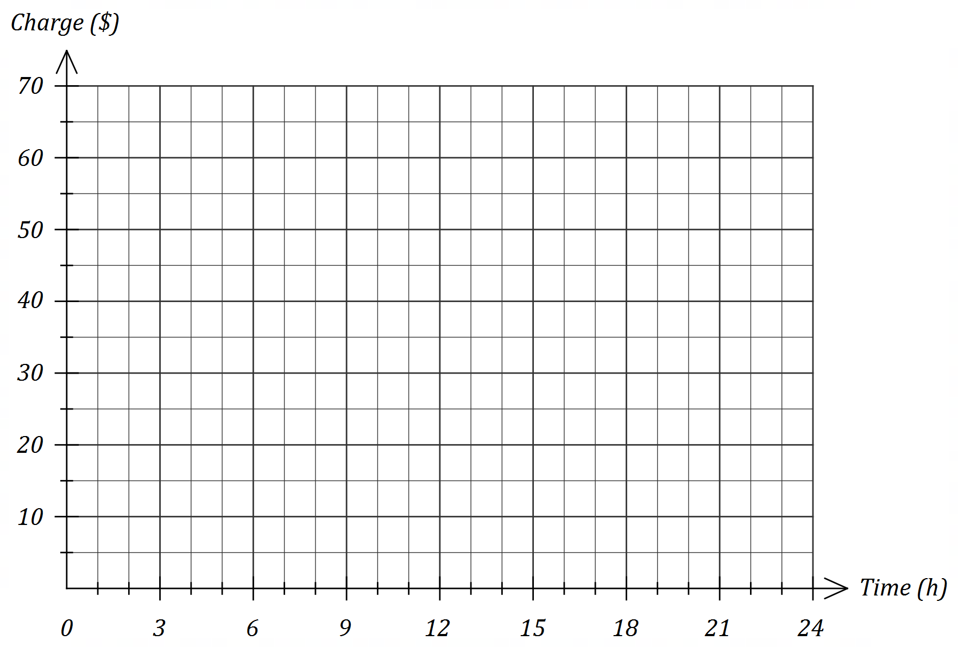

Question 3 (7 marks)

The graph of line $L_{1}$ with equation $y=ax+b$ is shown below.

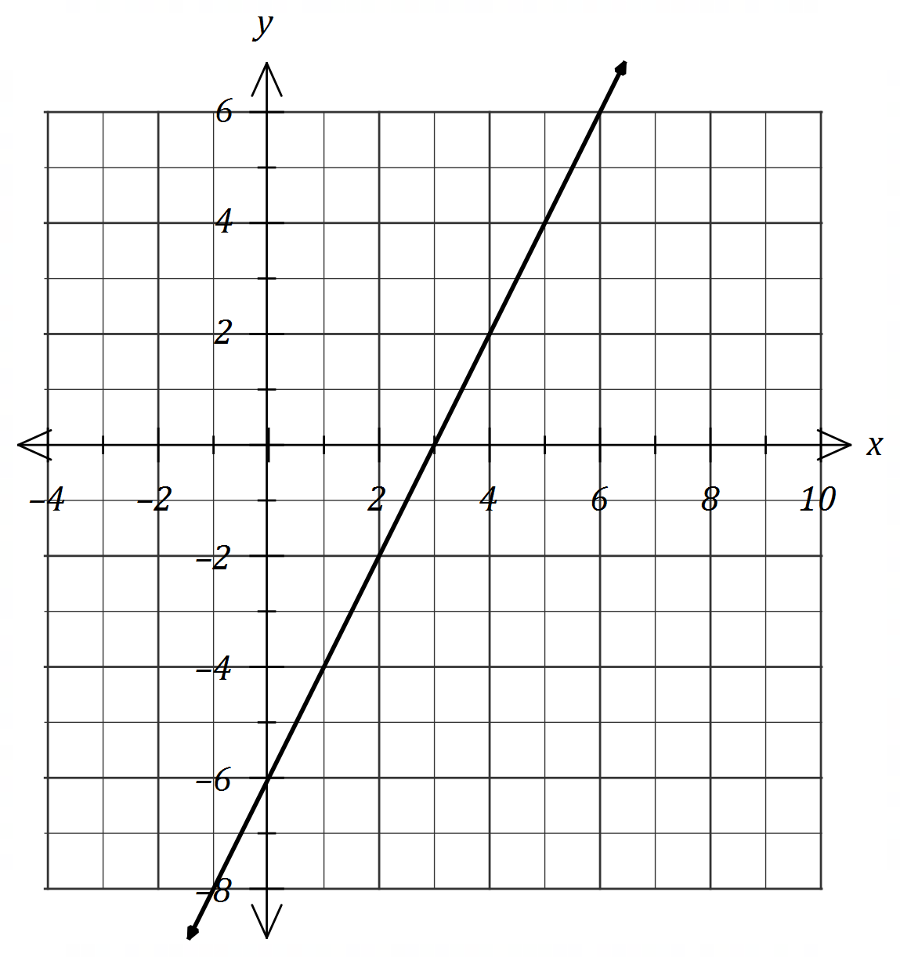

(a) Determine the value of the constant $a$ and the value of the constant $b$. (2 marks)

(b) Straight-line $L_{2}$ has equation $x+2y=8$.

(i) Draw $L_{2}$ on the axes above. (2 marks)

(ii) State the gradient of $L_{2}$. (1 mark)

(c) Determine the equation of the straight-line $L_{3}$ that passes through the origin and the point of intersection of lines $L_{1}$ and $L_{2}$. (2 marks)

Question 4 (9 marks)

The dot plot below shows the goal difference between each pair of teams playing in a weekend round of a soccer league.

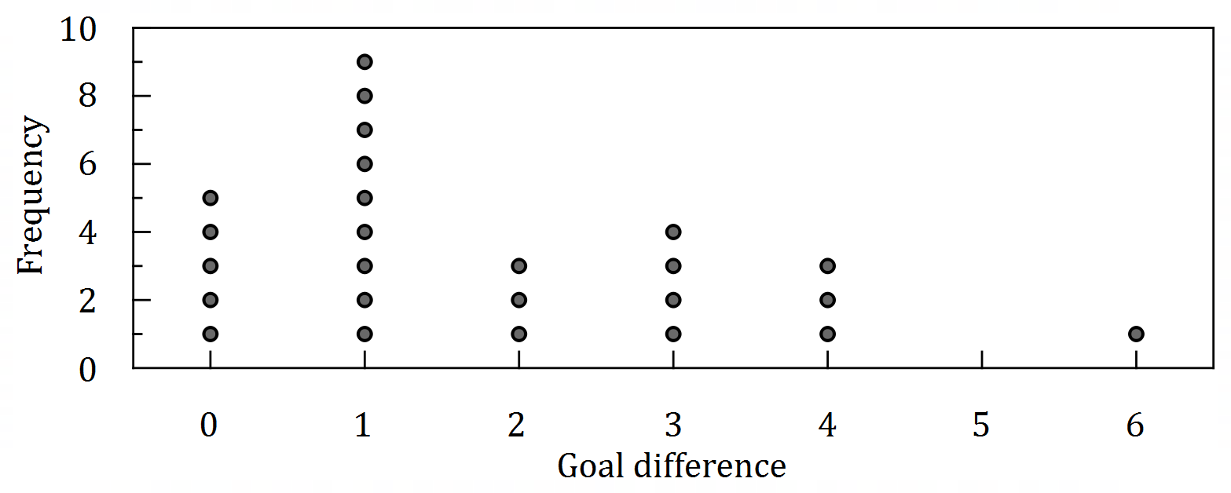

(a) State the number of games that did not end in a draw. (1 mark)

(b) Classify the type of variable that goal difference is by circling two of the following words:

(1 mark)

Categorical. Continuous. Discrete. Nominal. Numerical. Ordinal.

(c) Determine

(i) the median goal difference. (1 mark)

(ii) the mean goal difference. (2 marks)

(d) Describe the distribution of the dataset in terms of modality, shape and location. (3 marks)

(e) Describe the feature of the dot plot that would suggest the median would be less than the mean of the dataset. (1 mark)

Question 5 (7 marks)

The number of minutes that a group of students took to complete a task are listed below:

$$29, 26, 17, 29, 18, 26, 31, 25, 26, 35, 33, 28$$

(a) Construct an ordered stem-and-leaf plot to display this data. (3 marks)

(b) Identify, with justification, any outliers that may be present in the times. (4 marks)

Question 6 (5 marks)

(a) Solve the equation $3\left(x+5\right)-1=x-2(x-3)$. (2 marks)

(b) Use the formula $A=\frac{1}{2}\left(a+b\right)h$ to determine

(i) $A$ when $a=5.6, b=8.4$ and $h=20$. (1 mark)

(ii) $b$ when $A=33, a=4$ and $h=6$. (2 marks)

Question 7 (6 marks)

(a) Simplify $2\left[\begin{matrix}5 & 2 \\ -3 & 4\end{matrix}\right]-\left[\begin{matrix}6 & -1 \\ 2 & 7\end{matrix}\right]$. (2 marks)

(b) Given that $A=\left[\begin{matrix}-1 & 2 \\ 3 & 1\end{matrix}\right]$ determine $A^{2}$. (2 marks)

(c) Determine the value of $x$ and the value of $y$ given that $\left[\begin{matrix}2 \\ 5\end{matrix}\right]+x\left[\begin{matrix}-3 \\ 4\end{matrix}\right]=\left[\begin{matrix}-10 \\ 3y\end{matrix}\right]$. (2 marks)

Question 8 (6 marks)

At the start of the year $2002$, the difference in the ages of a mother and her child was $24$.

Let the age of the mother be $x$ and the age of her child be $y$ at the start of $2002$.

(a) Use the above information to write an equation relating $x$ and $y$. (1 mark)

Three years later, the mother was $5$ times as old as her child.

(b) Use this additional information to write another equation relating $x$ and $y$. (2 marks)

(c) Determine the age of the child at the start of the year $2019$. (3 marks)

Supplementary page

Question number: _________

Supplementary page

Question number: _________

Supplementary page

Question number: _________

Supplementary page

Question number: _________

© 2019 WA Exam Papers. Kennedy Baptist College has a non-exclusive licence to copy and communicate this document for non-commercial, educational use within the school. No other copying, communication or use is permitted without the express written permission of WA Exam Papers. SN245-143-1.